Updates Needed
  - Getting to a more polished, usable version

OVERVIEW: Purpose of the App
This App is intended to be a “Life Management” App – the purpose and intention behind this app is several fold:
- Establish and reinforce Positive “Daily” Healthy Habits that lead to personal/spiritual growth and “piece of mind”.
- Focus on making daily progress toward long term goals.
  - Daily Task list to stay focused on the main goals for the day.
- Create a historical record of the rest of my life
  - At the end of every year, I want to be able to review the highlights of my year.
    - Memorable Moments – The App must include a “well-integrated” journal function that allows me to capture thoughts about any aspect of my daily life, or just random thoughts whenever they arise.

    - Accomplishment of “Major Milestones” in each important area of my life (Love, Health, Freedom)
      - LOVE –
      - FREEDOM – completion and Launch of CNA Packet
      - HEALTH – Achieved ideal weight of 175 lbs.
    - Record all significant accomplishments (large or small)
    - Important dates of record:
      - Health Care Records:
        - Doctor Visits and results thereof.
      - Car Servicing Records (warranty terms):
        - Rebuilt Transmission Servicing Milage (odometer reading)
        - Oil Change Records

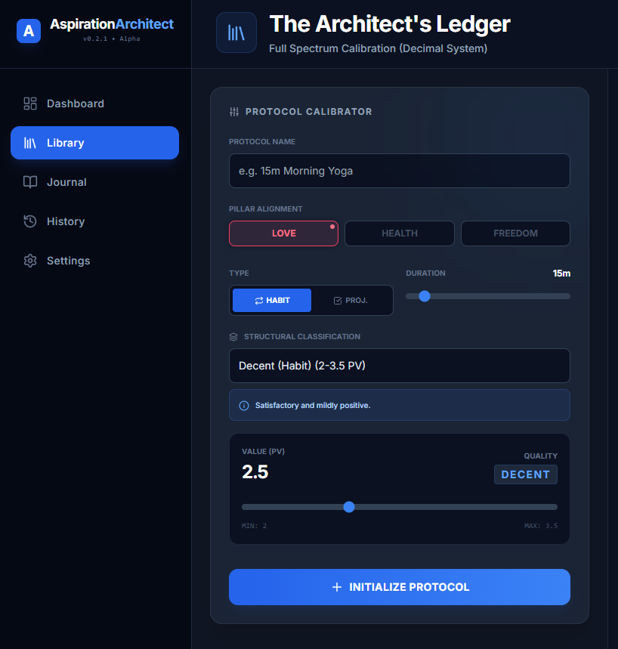 | The PROTOCOL CALIBRATOR needs to be updated to  protocol

Creating a well-structured, goal oriented “current day” Tasklist is a critical feature for this App.

